14. Backup and Restore (tar & gzip)
Task 1: Create a Backup
Step 1: Go to the Music folder
cd ~/Music
Step 2: Check the files
ls -l
Make sure the folder contains at least 3 files.
Step 3: Create the compressed backup
tar -czvf ~/music_backup.tar.gz -C ~ Music
Step 4: Verify the backup
ls -lh ~/music_backup.tar.gz
You can also check the contents:
tar -tzvf ~/music_backup.tar.gz
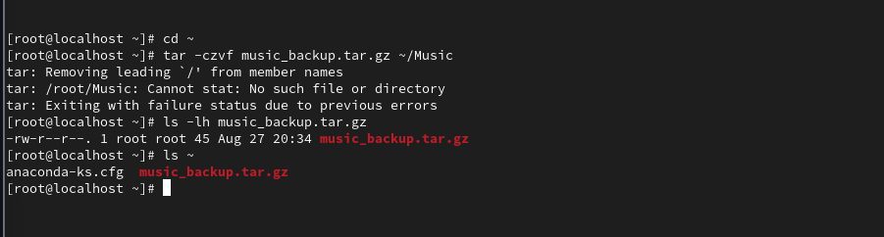

Task 2: Extract the Backup
Step 1: Create the restore directory
mkdir -p ~/restored_music
Step 2: Extract the backup
tar -xzvf ~/music_backup.tar.gz -C ~/restored_music --strip-components=1
Step 3: Verify the restored files
ls -l ~/restored_music
The files from the original Music folder should now be present in restored_music.


Task 3: Backup JPG Images Smaller Than 5MB
Step 1: Go to Downloads
cd ~/Downloads
Step 2: Create a list of JPG files smaller than 5MB
find . -type f -iname "*.jpg" -size -5M -print > /tmp/jpg_files
Step 3: Create the compressed backup
tar -czvf ~/images_backup.tar.gz --files-from=/tmp/jpg_files
Step 4: Verify the backup
ls -lh ~/images_backup.tar.gz
Check the files inside the archive:
tar -tzvf ~/images_backup.tar.gz
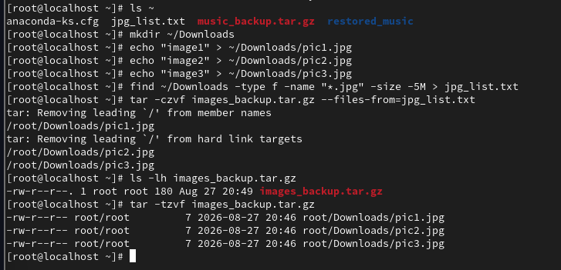

Task 4: Restore Only One Deleted File
Step 1: Check the Music folder
ls -l ~/Music
Choose one file that is already included in the backup.
Step 2: Delete one file
For example:
rm ~/Music/song.mp3
Replace song.mp3 with your actual filename.
Step 3: Verify that the file was deleted
ls -l ~/Music
Step 4: Restore only the deleted file
tar -xzvf ~/music_backup.tar.gz -C ~/Music Music/song.mp3 --strip-components=1
Replace song.mp3 with the actual deleted filename.
Step 5: Verify that the file is restored
ls -l ~/Music/song.mp3
If the file appears again, the restore was successful.
